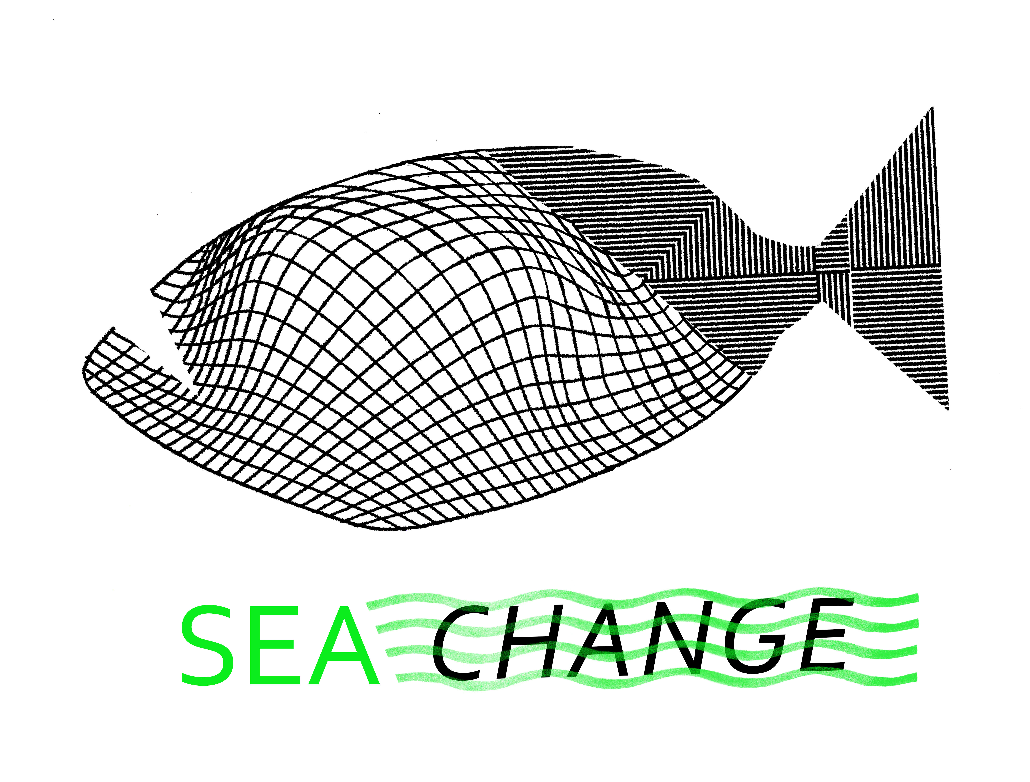
CONTRIBUTOR AGREEMENT

NAME of Illustrator/Author:

Address:

EMAIL and PHONE:

TITLE OF WORK SUBMITTED: SEA CHANGE Postcard, (two sided) created for the
SEA CHANGE exhibition in aid of an environmental charity

We need this form to be signed in order to reproduce your work in any catalogue/publication or book. Please scan a signed and fully completed copy of this form and email to Tobias Hickey at t.hickey@worc.ac.uk

Please write out in full in the space below the credit for the work that should be included in the book/catalogue.

By what name would you like to be credited in the publications:

I confirm that I am the sole author of the work and that I grant to the International Centre for the Picture Book in Society (ICPBS) a worldwide, non-exclusive licence (i.e. I retain the copyright) to publish the work in book and/or catalogue form, without charge, in all languages, including licensed editions, foreign language editions and new editions of this book. This licence shall be for the duration of copyright. I also grant the ICPBS permission to use the work in electronic formats of the book and in associated promotional material in relation to this title only. I promise that:

- no claims, litigation or other proceedings have been asserted and/or brought and no claims, litigation or proceedings are pending or threatened relating to the work;
- the work is original to me;
- the reproduction of the work will not infringe the rights of others;
• ICPBS is not responsible for any costs incurred as a result of my breach of this clause.

I agree that the original postcard will become the property of the ICPBS after its use in the exhibition SEA CHANGE in Bratislava, Slovakia in 2021 and could either be kept in a permanent collection or auctioned and all proceeds from any sales will be donated to the agreed environmental charity.

For and on behalf of the ICPBS Accepted and agreed by illustrator/author:

_____________________________ ______________________________

International Centre for the Picture book in Society
University of Worcester
Henwick Grove
Worcester
WR2 6AJ
United Kingdom

